Namami Gange – AI-Powered Water Quality Monitoring Platform

(Namami Gange – AI-Powered Water Quality Monitoring Platform)

**1. Abstract**

For Third World nations such as India, where rivers such as the Ganga are so essential culturally, economically, and spiritually, water pollution is a huge concern. Although initiatives such as Namami Gange have been made, still there is no high-tech real-time equipment to measure and monitor water quality at all. This paper proposes the use of machine learning for the analysis of sensor data to make accurate predictions about levels of pollution in any artificial water quality monitoring systems. To take the right action at the right time, a real-time graphical view of the condition of water is an accurate reading of the condition. Secure access is provided using the combined email OTP authentication and Firebase authentication. To make the request at the right time, a real-time graphical representation of the state of water gives the correct reading. Firebase authentication combined with email OTP authentication gives a safe entry. The simple interface of the application, designed using Firebase and Flutter, makes it easy for both users as well as authorities to use. The solution should promote awareness, enable data-informed decision-making, and foster long-term thinking about clean bodies of water by giving users projected information and steering data.

**2. Introduction**

It is crucial to millions of Indians for industrial purposes, irrigation, and drinking. Due to population pressure, growing development, and lack of garbage disposal, it has become one of the world's most polluted rivers. The sluggish, stagnant variable, and time-consuming nature of conventional manual water analysis is the strongest rationale for developing a faster real-time system of water quality monitoring. The Namami Gange scheme suggests a platform based on artificial intelligence for monitoring water quality to address this requirement. This is a novel approach that combines technological developments such as Firebase, artificial intelligence, and cross-platform mobile app development with environmental science. The technology employs intelligent data analysis and forecasting capability to facilitate real-time monitoring of water quality. The users can input information from water samples to get real-time estimates of the degree of pollution. For the purpose of quick response, the system also provides real-time alerts when the quality of water goes below certain safety levels.

The app can both be used by residents and authorities, with its straightforward Flutter design and secure email OTP verification as well as Firebase authentication. In offering actionable knowledge to stakeholders, this technology-enabling strategy strives to enable enhanced decision-making during the restoration as well as preservation of the Ganga River's health.

**3. Methodology**

Step-by-Step Workflow:

**Step 1: Data Collection**

* Water quality dataset downloaded from the Central Pollution Control Board (CPCB)
* Important parameters: Biochemical Oxygen Demand (BOD), Chemical Oxygen Demand (COD), pH level, Turbidity, Dissolved Oxygen (DO), and Temperature

**Step 2: Data Preprocessing**

* Null Value Handling: Imputed or eliminated missing values.
* Label Encoding: Converted categorical labels to numerical values.
* Normalization/Scaling: Used MinMaxScaler to normalize data.
* Train-Test Split: Split dataset with an 80-20 ratio using train_test_split().

Outlier Detection: Utilized data visualization to identify outliers in such parameters as BOD and DO.

**Step 3: Model Building**

* Built machine learning models (Random Forest and XGBoost) utilizing Google Colab.
* Trained on labeled datasets to predict the level of pollution as low, moderate, or high Achieved R² score of 0.89 and MAE of 0.42 for the test dataset

**Step 4: Frontend Development**

* Developed with Flutter for cross-platform compatibility (Android, iOS, and web).
* Features are user authentication, parameter input fields, and real-time display of predictions

**Step 5: Backend and Authentication**

* Utilized Firebase Authentication for secure user management.
* Implemented Email OTP verification through Firebase Functions.
* User information and prediction history stored in Firebase Firestore

**Step 6: Deployment**

Registered users can:

* Input and upload water quality parameters.
* View predictions of pollution levels

Monitor historical data

Access informative dashboards.

**5. Hardware/Software Required**

Hardware (Optional for Simulation)

* Arduino Uno / Raspberry Pi
* pH Sensor, Turbidity Sensor, Temperature Sensor
* GSM/WiFi Module for data transmission

**Software**

| **Component** | Tool/Framework |
| --- | --- |
| **AI Model** | Python (pandas, sklearn, XGBoost) |
| **Code Platform** | Google Colab, VS Code |
| **Frontend** | Flutter |
| **Backend** | Firebase Auth, Firestore, Firebase Functions |
| **Version Control** | Git, GitHub |
| **Documentation** | MS Word / Google Docs |
| **Presentation** | PowerPoint |

**5. Related Work (If Any)**

**Existing Studies and Platforms:**

1. Central Pollution Control Board (CPCB): Monitors water quality but is not publicly available in real time using AI.  
   2. Intelligent Water Quality Monitoring Systems: They primarily use IoT sensors with minimal analytics, but are generally too expensive or too specialized.  
     
   3.AI for Water Quality Research: Support Vector Machines, Random Forest, and Neural Networks have been employed in research to train on datasets, but typically for prediction alone, without frontend usage or user interface.

**Key Takeaways:**

 Current systems either do not have real-time predictions or user interfaces.  
• One solution that combines AI, user login, and mobile interface in one integrated platform is not publicly available.  
• Our project fills this gap by not only making the platform predictive but also interactive and user-friendly.

**6. Experimental Results**

Model Performance:

* **Model Used:** Random Forest Regressor
* R² Score: 0.89
* **Mean Absolute Error**: 0.42
* **Accuracy for Pollution Category Classification**: 91.3%

**Visualization:**

* Predicted vs. Actual plot for pollution level
* Confusion matrix for classification
* Feature importance bar chart (showing BOD and COD as most influential).

**7. Conclusions**

This research shows that cloud computing and artificial intelligence technology can play a substantial role in monitoring environmental conditions, such as water quality. The proposed platform, besides accurately predicting the levels of pollution, provides a safe and simple interface for continuous monitoring. Due to the combination of Firebase and Flutter, it is scalable and accessible. Through the provision of real-time data and AI-driven predictions, the system enables authorities to make informed decisions in a timely manner and engage the public in river conservation activities.

**8. Future Scope**

* + Live Sensor Integration: Install physical sensors on riverbanks for 24x7 monitoring
  + Geolocation Mapping: GPS tagging of data for visualization of pollution over regions.
  + Integration with Government: Integrate with Jal Shakti Abhiyan or Namami Gange for national rollout.
  + Multilingual Support: Implement the app in local languages for greater public engagement.
  + AI Optimization: Investigate ensemble learning and deep learning to make more precise long-term forecasts.
  + Citizen Reporting: Enable users to report pictures and local observations for community-based monitoring.

**9. GitHub Link of Your Complete Project**

**Once your files (code, dataset, model files, screenshots, PPT, and report) are ready:**

**🔗 GitHub Repository Link: [Paste your repo link here once created]**

**10.UI/UX**

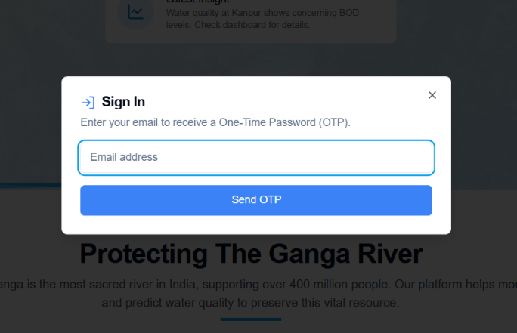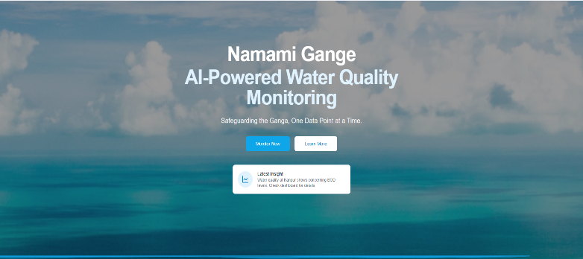

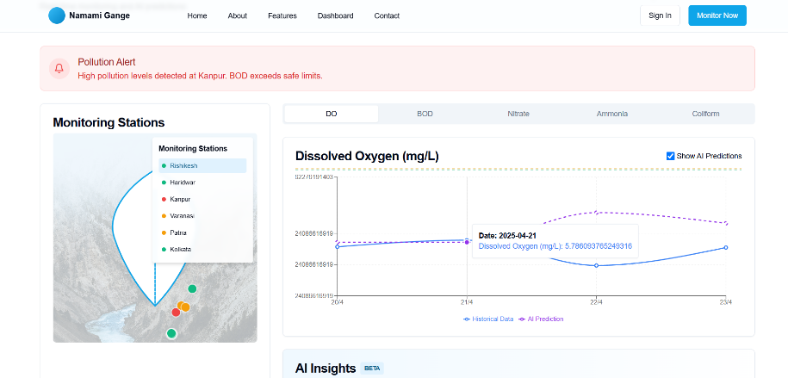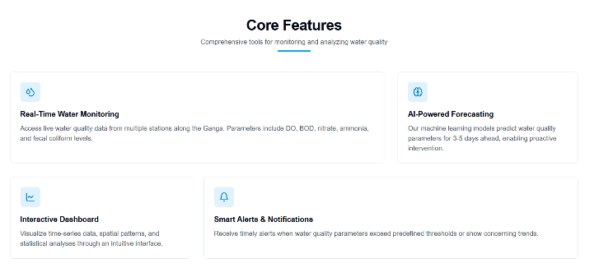



**LOGO**